# **Instruction on how to use the Smart Glasses**

1. **Wear the device:**

* Place the display infront of your dominant eye.
* Adjust the holding strap to your head size and place the device on your head.
* The display must be slightly below your eye so it does not obstruct your view.
* On the opposite side of camera/display is power button. Press on once and quick if the display is off. This activates the device.

1. **Naviagtion:**
2. This device is completly hands free and controled by voice commands.

**SAY WHAT YOU SEE!**

1. You see text, buttons, pictures and videos. Navigate to your desired destination by reading the buttons loud (without shouting!).

Example of buttons for navigation:  

1. In case you need to adjust brightness or volume, call „Show Help“, then „My Controls“. Do not change anything else otherwise ask supervisors for a help.
2. **How to navigate pictures and videos:**
3. For playing the videos you must say „**Play**“. Once it is played it can not be stoped but only exited.
4. Say “**close**“ to stop the video.
5. To go to Homepage, say „**Home“**
6. **Recording a Video:**

* Say "Navigate Home," then "My Programs."
* Say "My Camera" to access the camera function.
* Finally, say "Start Recording" to begin recording a video.

Please remember to familiarize yourself with these instructions and utilize the smart glasses responsibly for a smooth and efficient experience!!

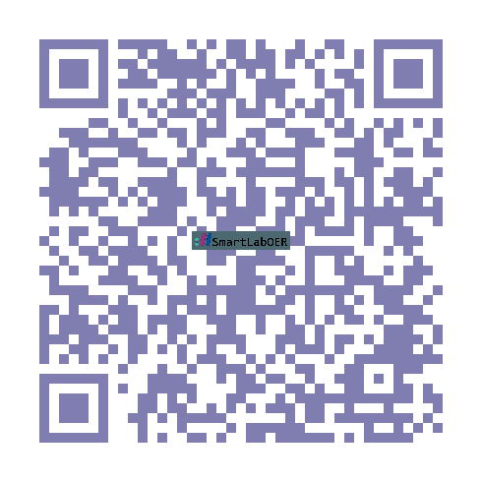

**Scan for SmartLab HomePage**

1. **Say “Navigate Home“**
2. **Then “My Programs“**
3. **Finally “Scan QR Code“**
4. **Adjust the camera to position the QR code in the scan area.**

## **Student FeedBack Survey**

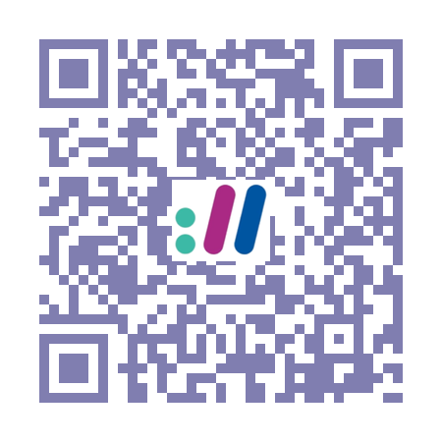

**We kindly request all students to take a moment to fill out the survey above. Your valuable feedback regarding the smartglasses and your experience in the lab will greatly help us improve and enhance the learning environment. Thank you for your participation!**

**Scan the QR code to access the survey.**